PROJECT DOCUMENTATION

InsightStream: Navigate the News Landscape

1.INTRODUCTION

* PROJECT TITLE : InsightStream: the News Landscape

* Team ID :

* Team Leader :

Kalai Yazhini .V

[&yazhinivijayan09@gmail.com](mailto:&yazhinivijayan09@gmail.com)

* Team Members :

_ Saranya.S

[&saranyasakthi2007@gmail.com](mailto:&saranyasakthi2007@gmail.com)

_Priyadharshini.G

[&jayamala1877@gmail.com](mailto:&jayamala1877@gmail.com)

_Shanthini.A

[&shanthinisarfun@gmail.com](mailto:&shanthinisarfun@gmail.com)

2. PROJECT OBJECTIVE

The primary objective of InsightStream is to establish a user-friendly platform tailored for individuals who are passionate about staying informed, exploring diverse news topics, and accessing the latest updates.

Our key goals include:

User-Friendly Experience: Develop an interface that is intuitive and easy to navigate, ensuring users can effortlessly access, save, and share their preferred news articles.

Comprehensive News Management: Provide robust features for organizing and managing news content, incorporating advanced search options for a personalized news experience.

Technology Stack: Employ cutting-edge web development technologies, such as React.js, to ensure an efficient and enjoyable user interface.

Features of InsightStream:

News from API Sources: Access a vast library of global news spanning various categories and interests, ensuring a well-rounded coverage of current affairs.

Visual News Exploration: Discover breaking stories and explore different news categories through curated image galleries, enhancing the visual appeal of news discovery.

Intuitive Design: Navigate the application seamlessly with a clean, modern interface designed for optimal user experience and clarity in information presentation.

Advanced Search Feature: Easily access news articles on specific topics through a powerful search feature, providing users with tailored news content based on their interests.

PRE-REQUISITES

Here are the key prerequisites for developing a frontend application using React.js:

Node.js and npm: Node.js is a powerful JavaScript runtime environment that allows you to run JavaScript code on the local environment. It provides a scalable and efficient platform for building network applications.

Install Node.js and npm on your development machine, as they are required to run JavaScript on the server-side.

Download: https://nodejs.org/en/download/

Installation instructions: https://nodejs.org/en/download/package-manager/

React.js: React.js is a popular JavaScript library for building user interfaces. It enables developers to create interactive and reusable UI components, making it easier to build dynamic and responsive web applications.

Install React.js, a JavaScript library for building user interfaces.

Create a new React app:

npx create-react-app my-react-app

Replace my-react-app with your preferred project name.

Navigate to the project directory:

cd my-react-app

Running the React App:

With the React app created, you can now start the development server and see your React application in action.

Start the development server:

npm start

This command launches the development server, and you can access your React app at http://localhost:3000 in your web browser.

HTML, CSS, and JavaScript: Basic knowledge of HTML for creating the structure of your app, CSS for styling, and JavaScript for client-side interactivity is essential.

Version Control: Use Git for version control, enabling collaboration and tracking changes throughout the development process. Platforms like GitHub or Bitbucket can host your repository.

Git: Download and installation instructions can be found at: https://git-scm.com/downloads

Development Environment: Choose a code editor or Integrated Development Environment (IDE) that suits your preferences, such as Visual Studio Code, Sublime Text, or WebStorm.

Visual Studio Code: Download from https://code.visualstudio.com/download

Sublime Text: Download from https://www.sublimetext.com/download

WebStorm: Download from https://www.jetbrains.com/webstorm/

To clone and run the Application project from GitHub:

Follow below steps

Install Dependencies:

Navigate into the cloned repository directory and install libraries:

cd news

npm install

Start the Development Server:

To start the development server, execute the following command:

npm start

Access the App: Open your web browser and navigate to http://localhost:3000.

You have successfully installed and set up the application on your local machine. You can now proceed with further customization, development, and testing as needed.

PROJECT STRUCTURE

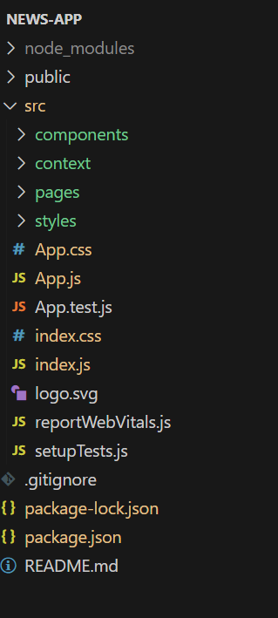

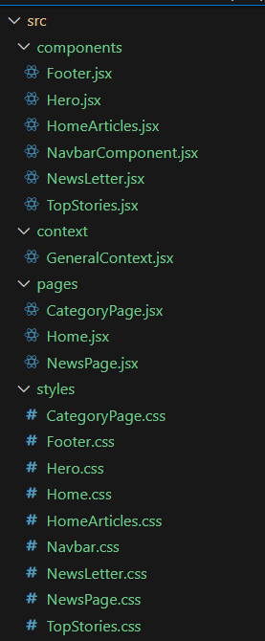

In this project, we’ve split the files into 4 major folders, Components, Context, Pages and Styles. In the pages folder, we store the files that acts as pages at different URLs in the application. The components folder stores all the files, that returns the small components in the application. The context Api will be coded in the context folder. All the styling css files will be stored in the styles folder.

PROJECT FLOW

Project demo:

Before starting to work on this project, let’s see the demo.

Demo link: https://drive.google.com/file/d/11uBQ3q6BK13SlFLz1ydlbM48QeqWecFL/view?usp=sharing

Use the code in: <https://drive.google.com/drive/folders/1E9QxUsJfs_W1pTK3qt8lB_yWaYAecCWd?usp=drive_link>

PROJECT SETUP AND CONFIGURATION:

Installation of required tools:

Open the project folder to install necessary tools

In this project, we use:

React Js

React Router Dom

React Icons

Bootstrap/tailwind css

Axios

For further reference, use the following resources

https://react.dev/learn/installation

https://react-bootstrap-v4.netlify.app/getting-started/introduction/

https://axios-http.com/docs/intro

<https://reactrouter.com/en/main/start/tutorial>

PROJECT DEVELOPMENT:

Setup the Routing paths

Setup the clear routing paths to access various files in the application.

* Develop the Navbar and Hero components
* Code the popular categories components and fetch the categories from ***newsapi***.
* Also, add the trending news in the home page.
* Additionally, we can add the component to subscribe for the newsletter and the footer.
* Now, develop the category page to display various news articles under the different categories.

**Important Code snips:**

* **Fetching Top/Trending news**

Develop the Navbar and Hero components

Code the popular categories components and fetch the categories from newsapi.

Also, add the trending news in the home page.

Additionally, we can add the component to subscribe for the newsletter and the footer.

Now, develop the category page to display various news articles under the different categories.